**TEST 23 Nov 2024**

1. Create user group and assign that group with the read-only policy for EC2 and S3 service 10M

a. Creating user group – testusergroup23

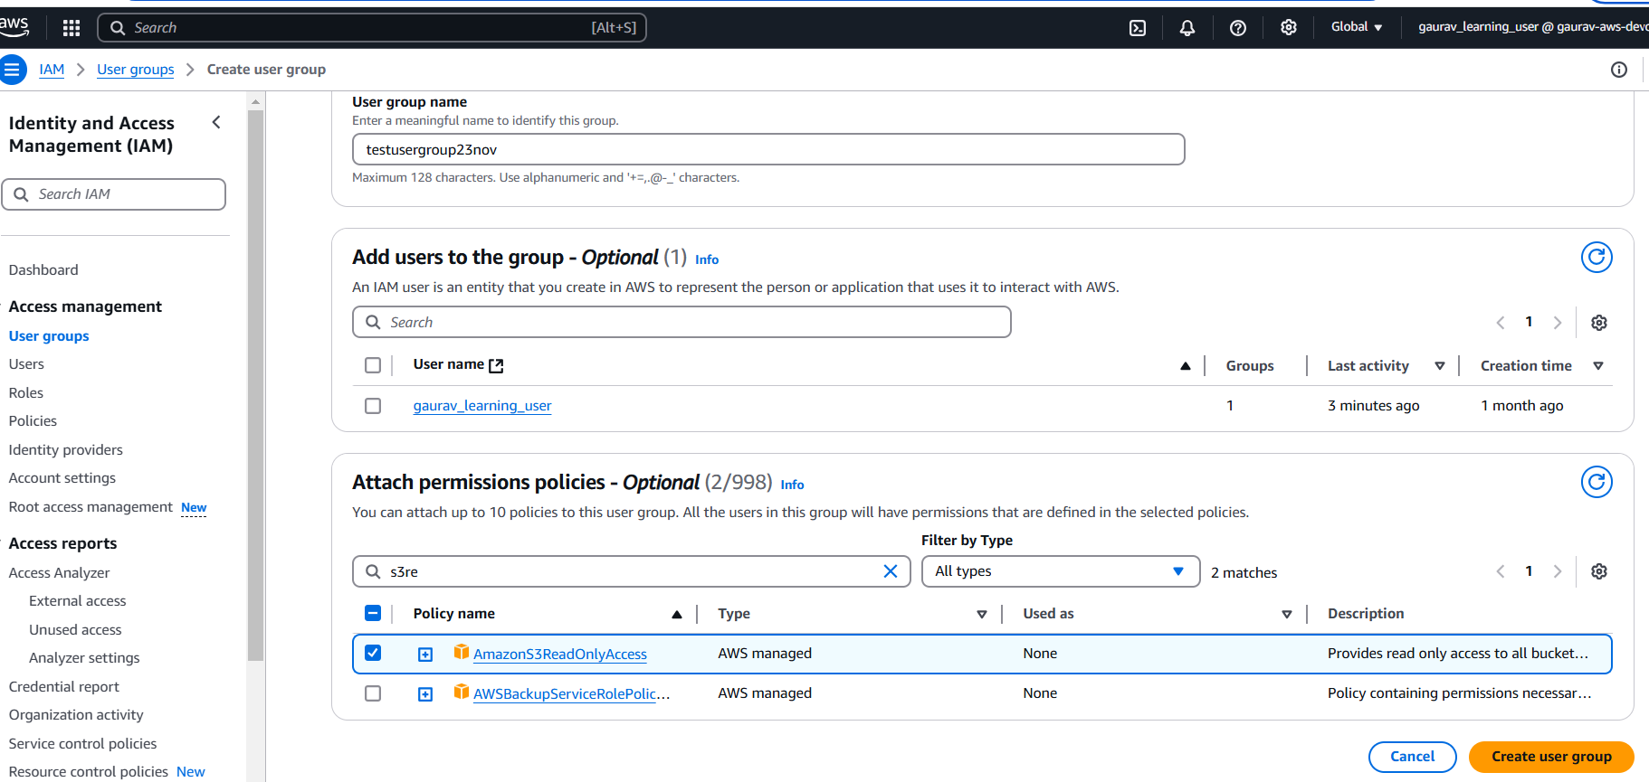

b. Assigned READ-ONLY permission for EC2 and S3

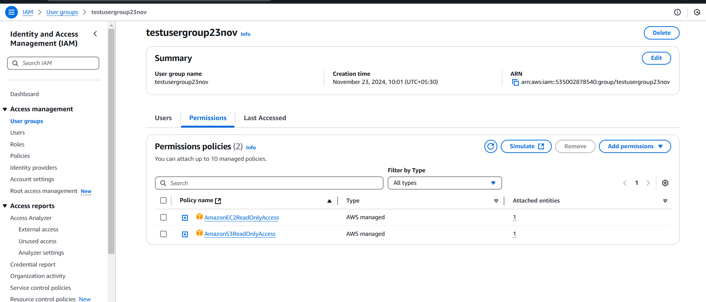

4. Launch EC2 instance and try to attach EBS vol of 4GB with it. After that remove the vol and then detach it from EC2. Take snapshot before detaching.

Creating new instance using details used during class

* Existing keypair
* Existing security group with SSH and HTTP inbound rule
* EC2 user data for first time system boot

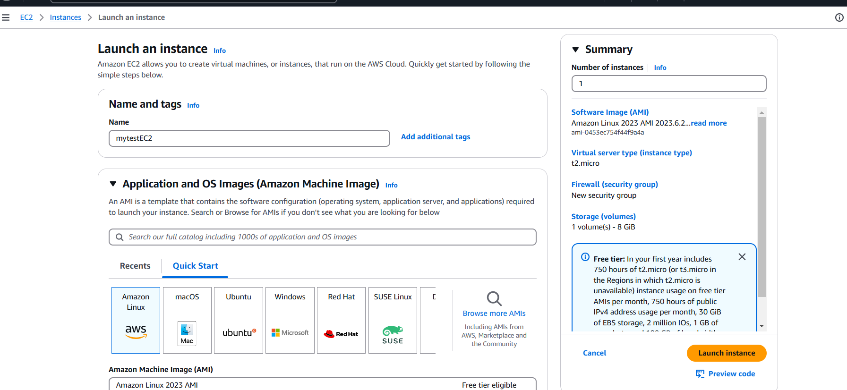

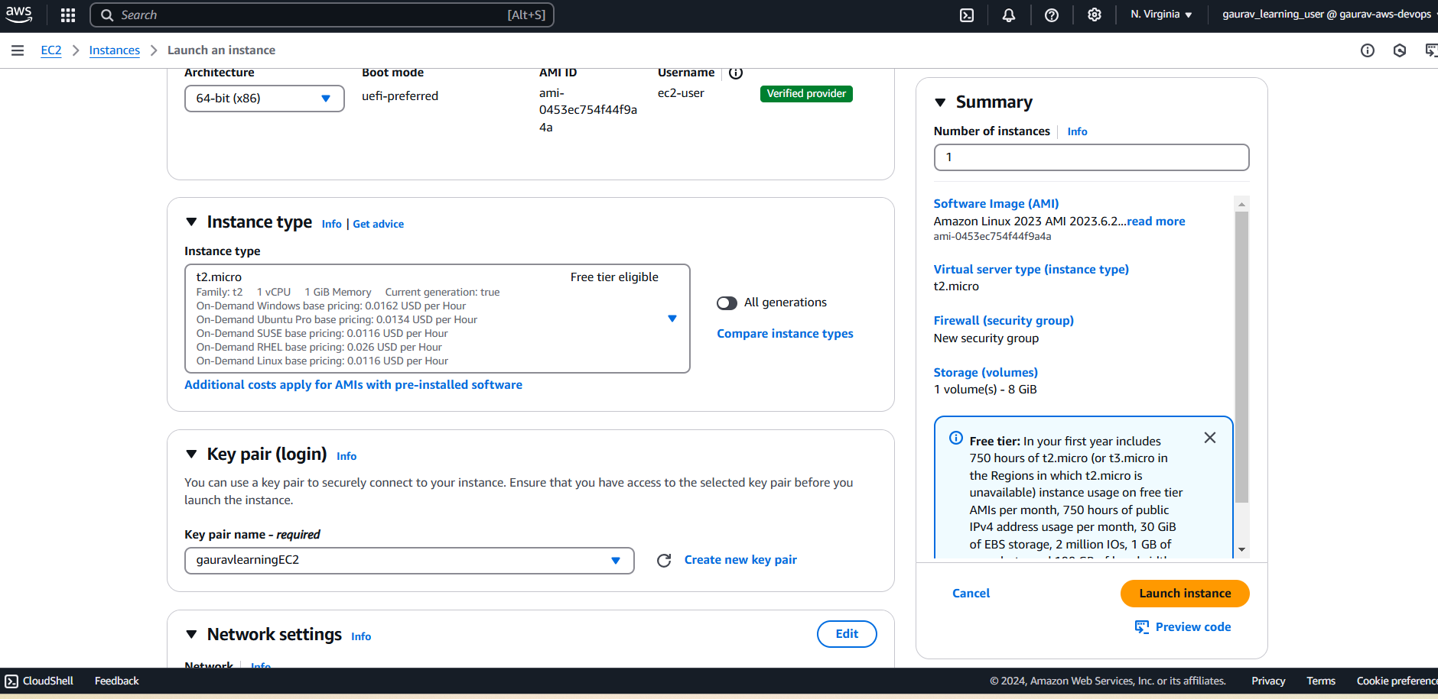

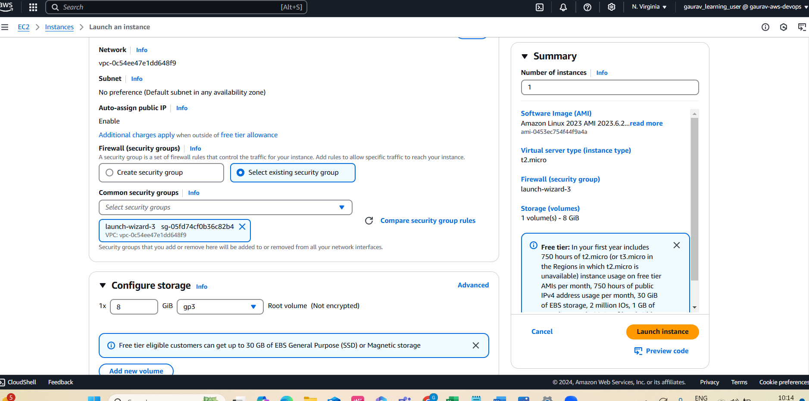

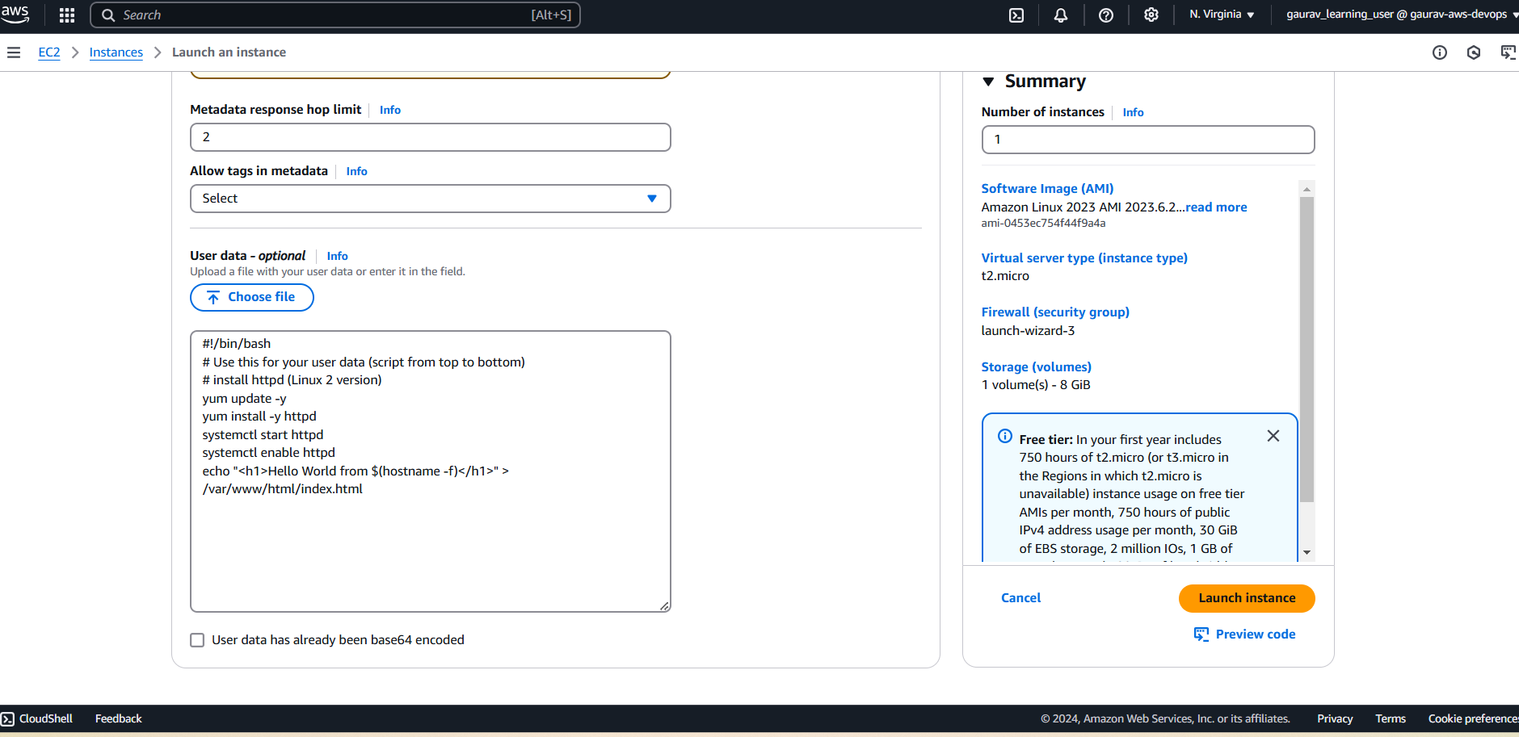

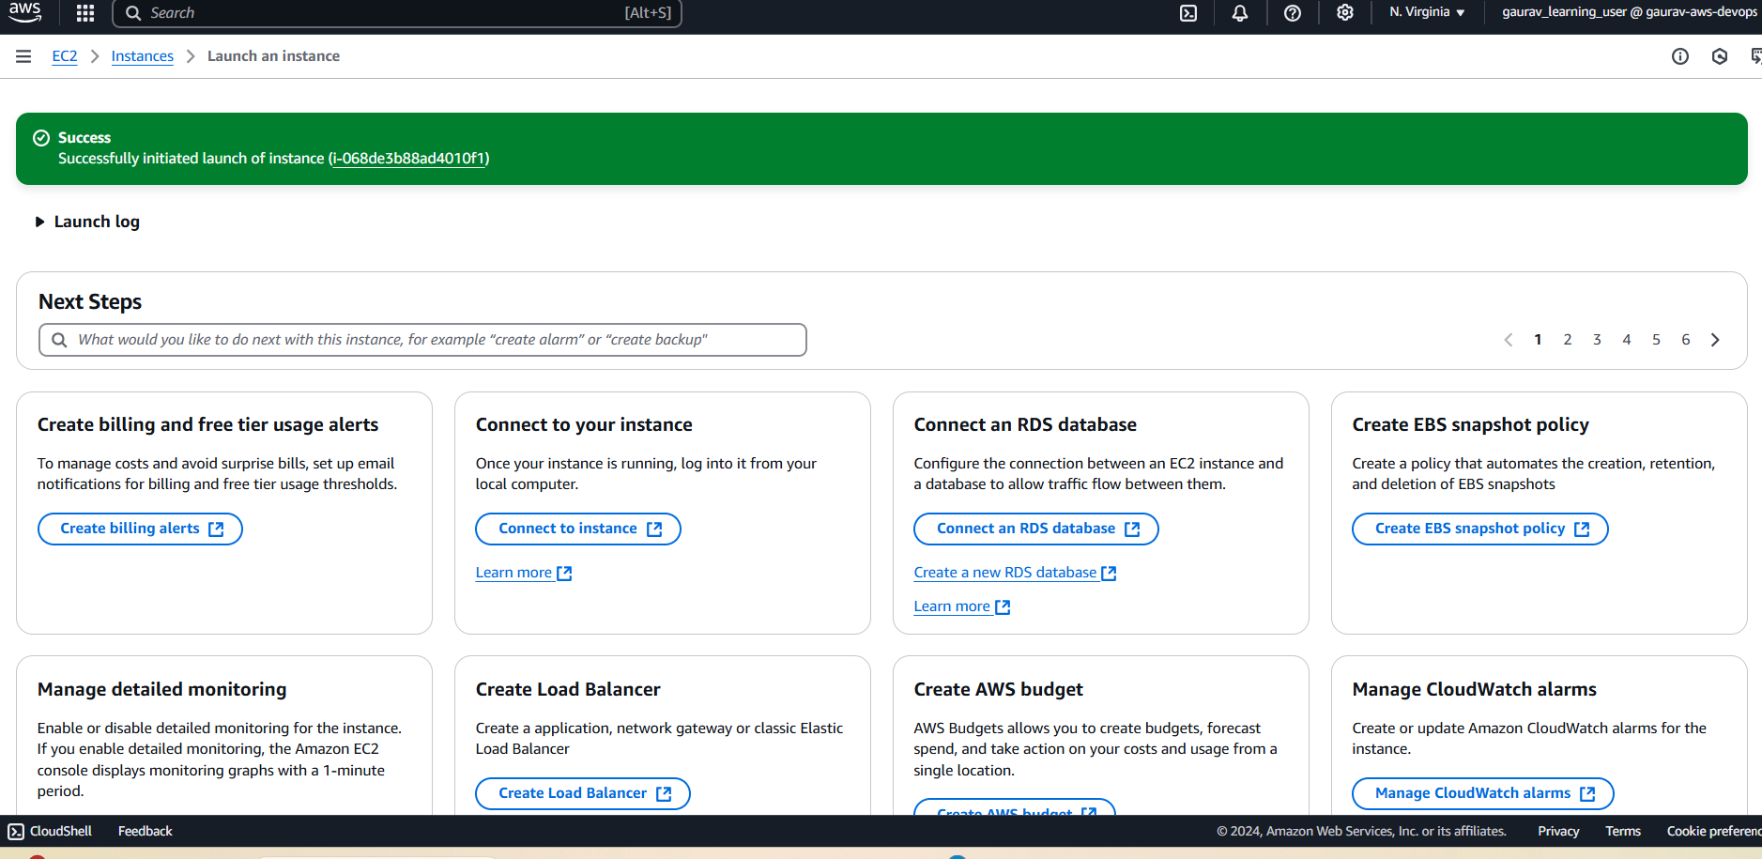

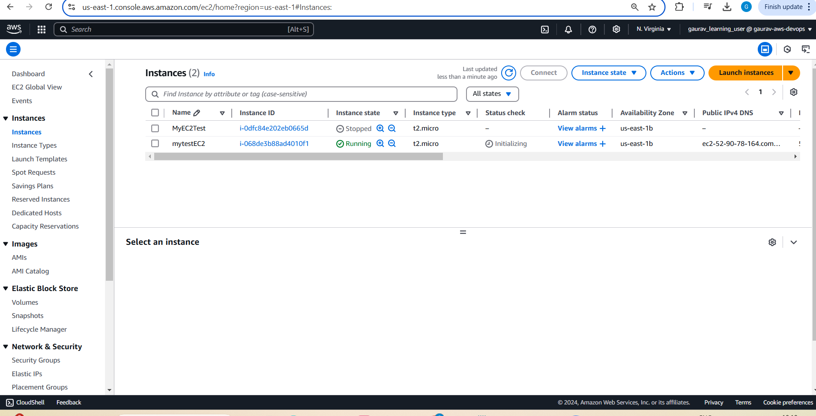

EC2 instance created in AZ 1b with default vol [vol-0830727beab2cf761](https://us-east-1.console.aws.amazon.com/ec2/home?region=us-east-1#VolumeDetails:volumeId=vol-0830727beab2cf761)– EBS to be created there

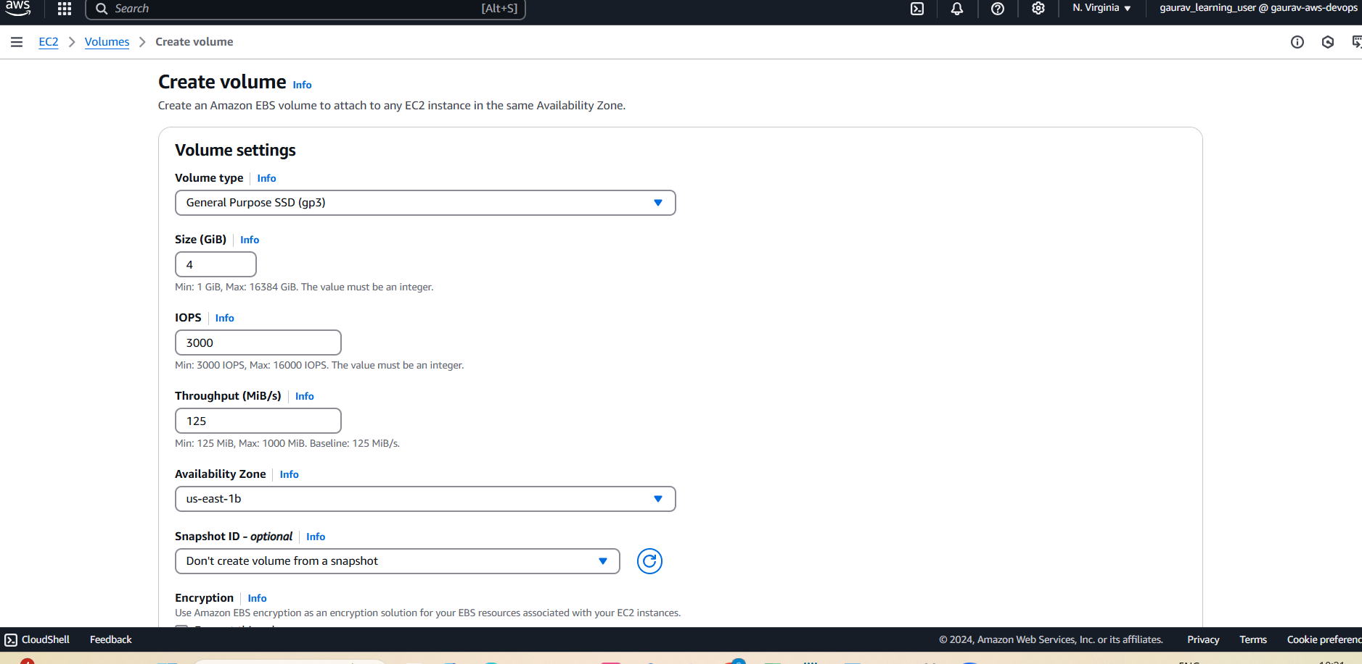

4 GB Vol created

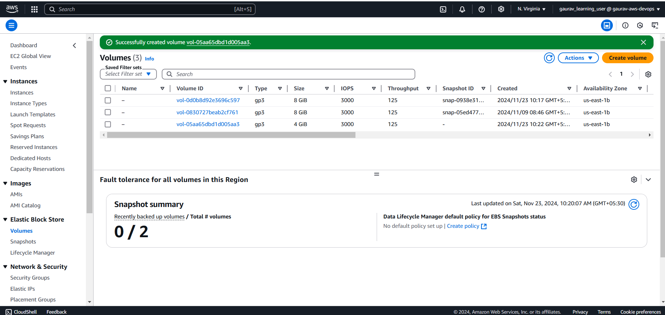

Attaching it

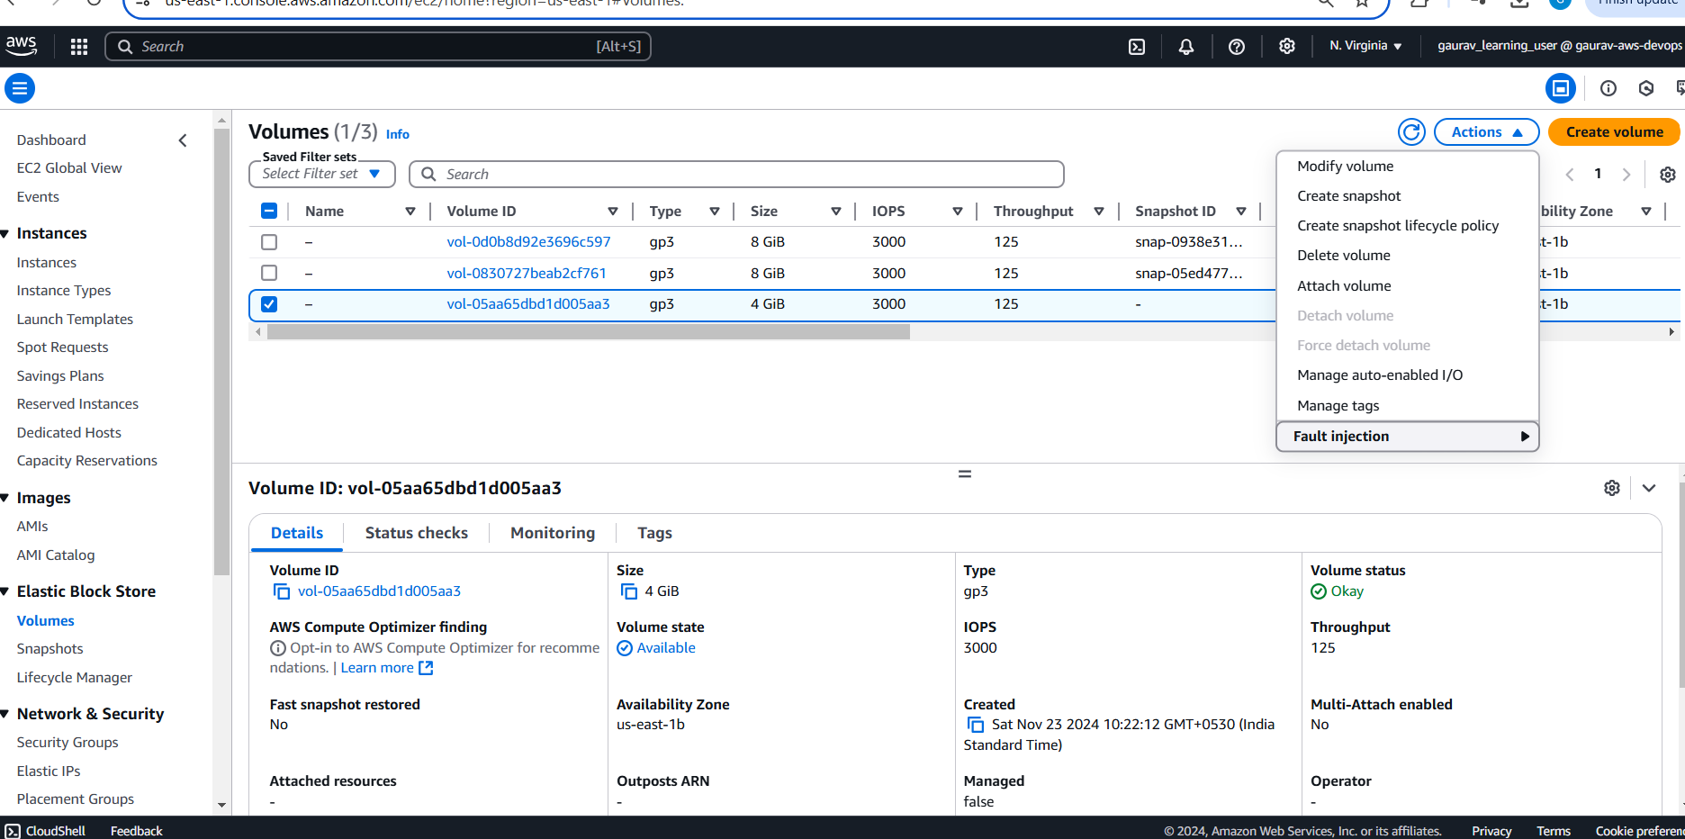

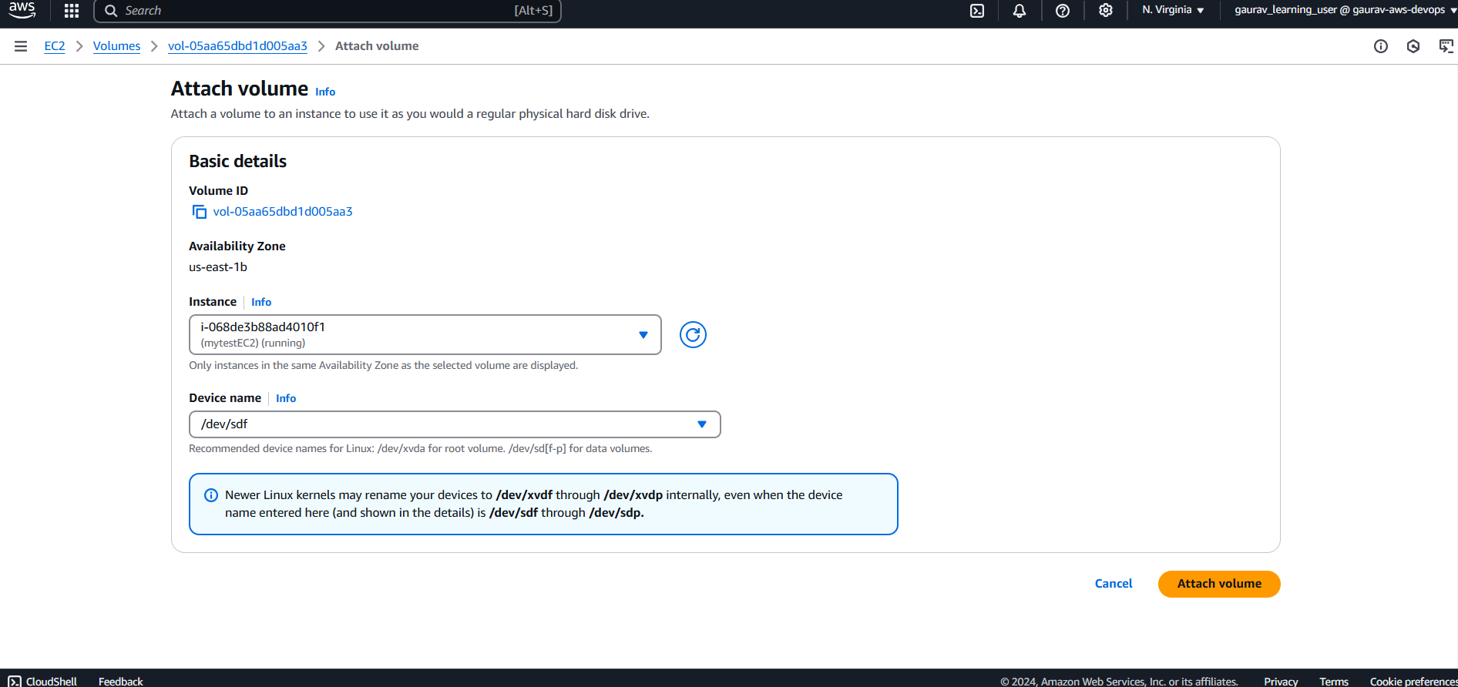

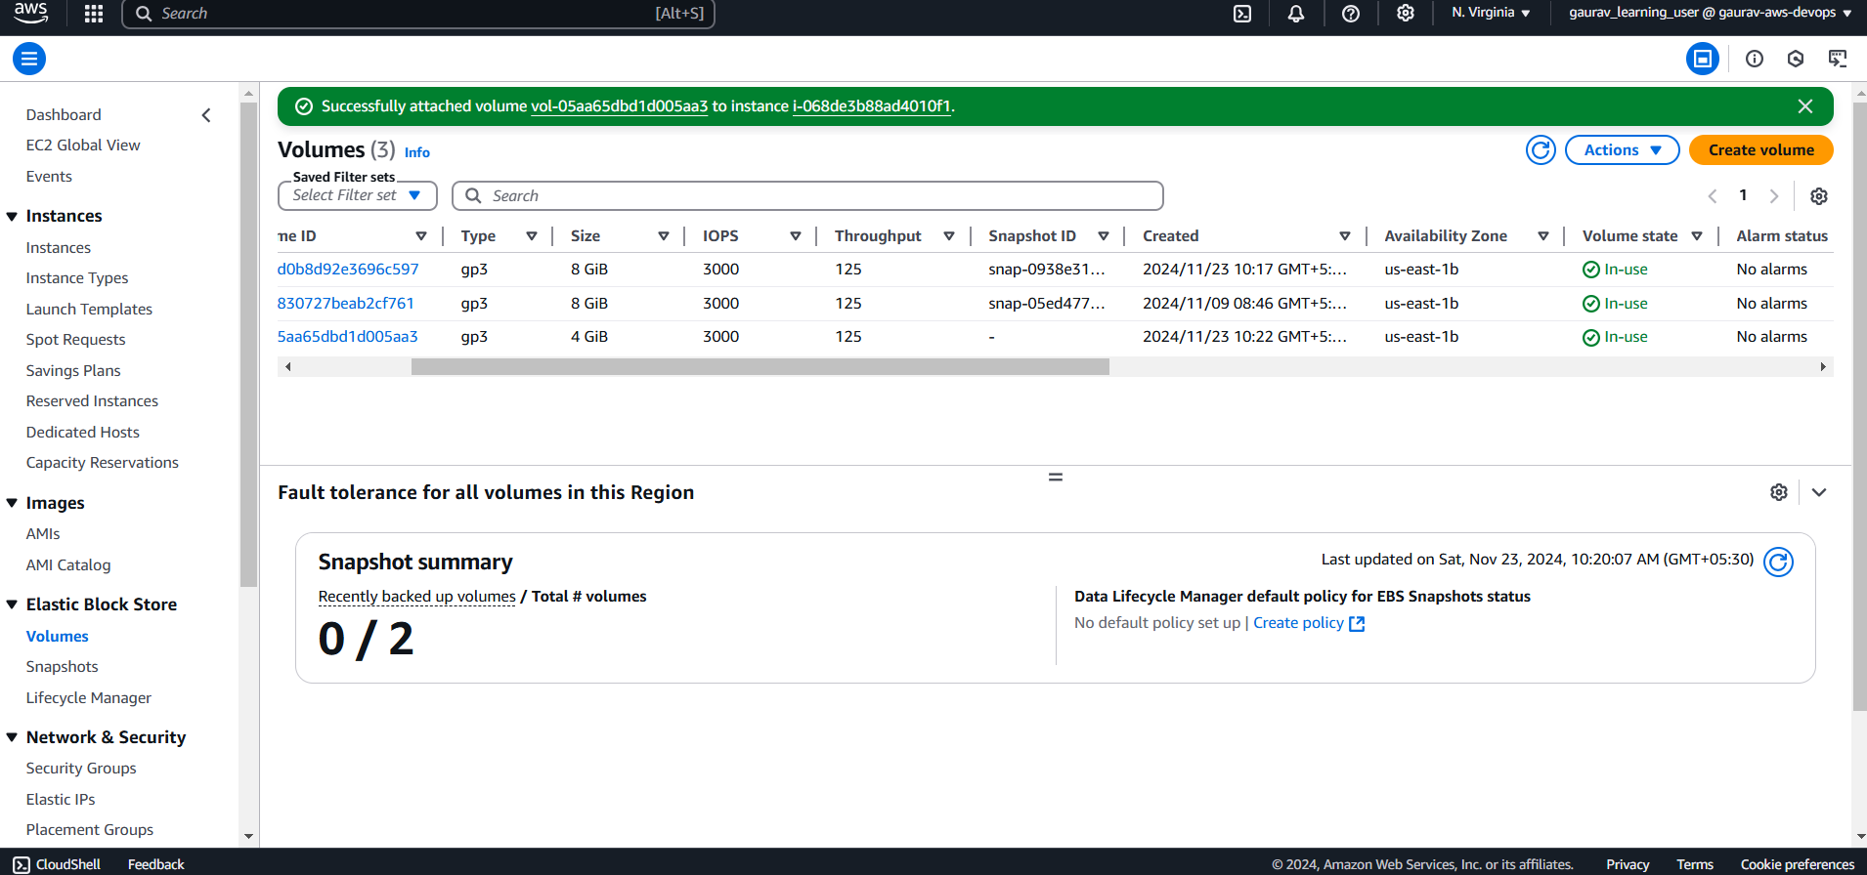

Instance view showing attached

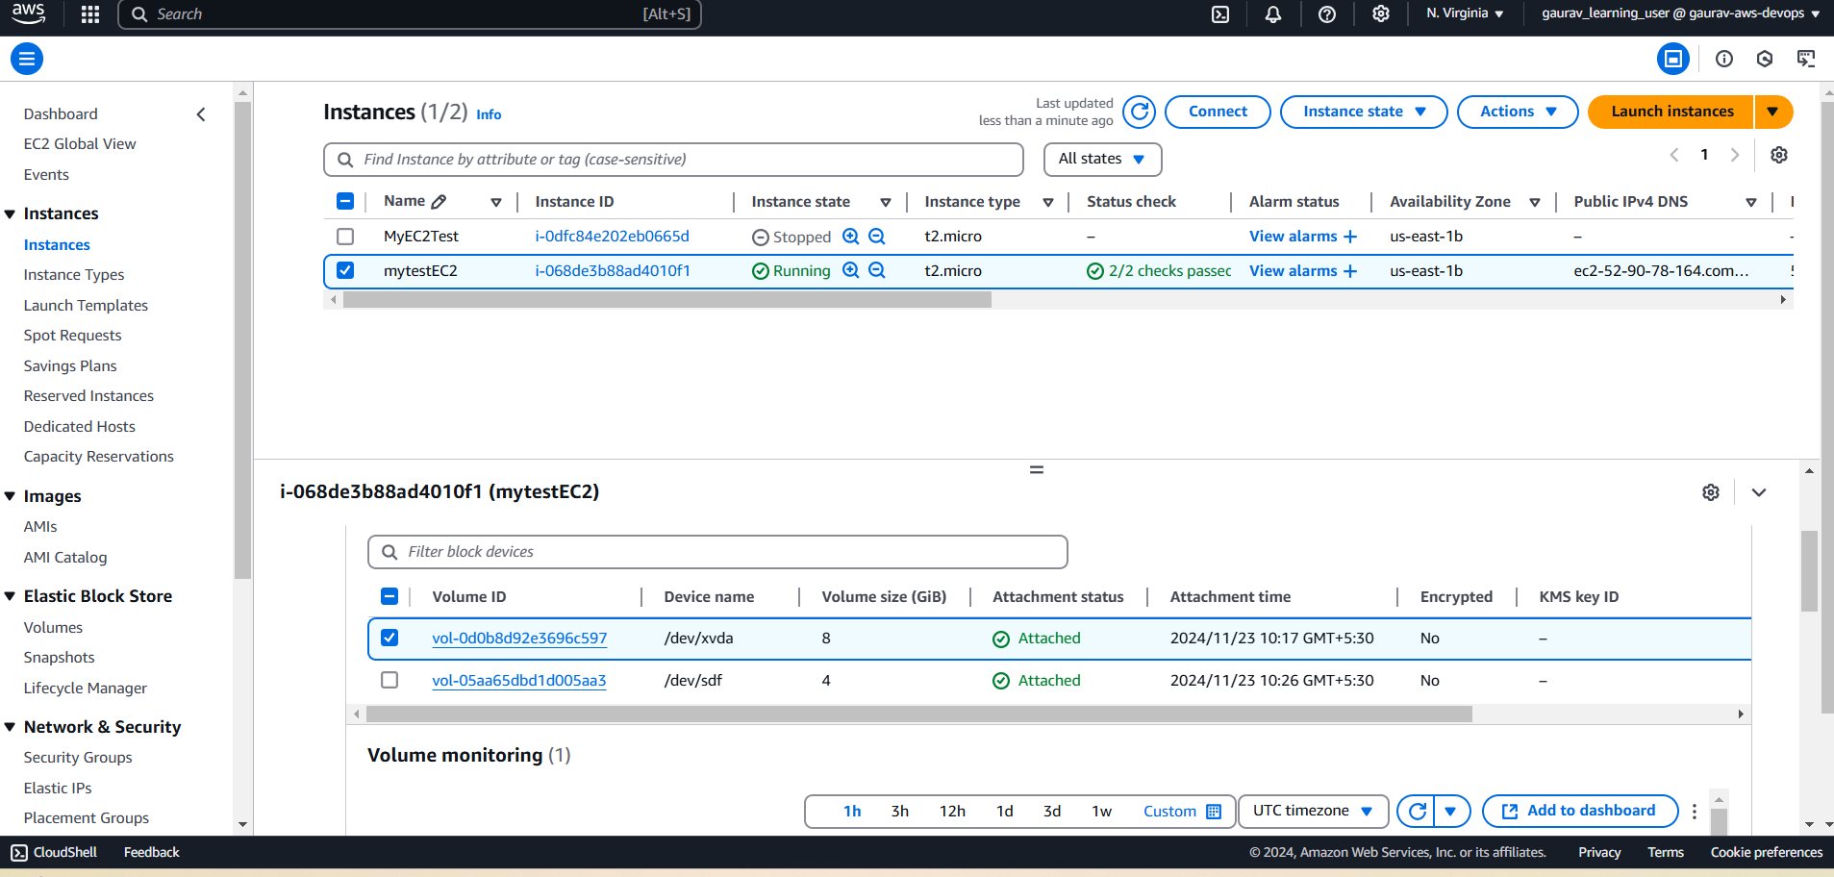

Connect Linux web version and use lsblk to see attached vol

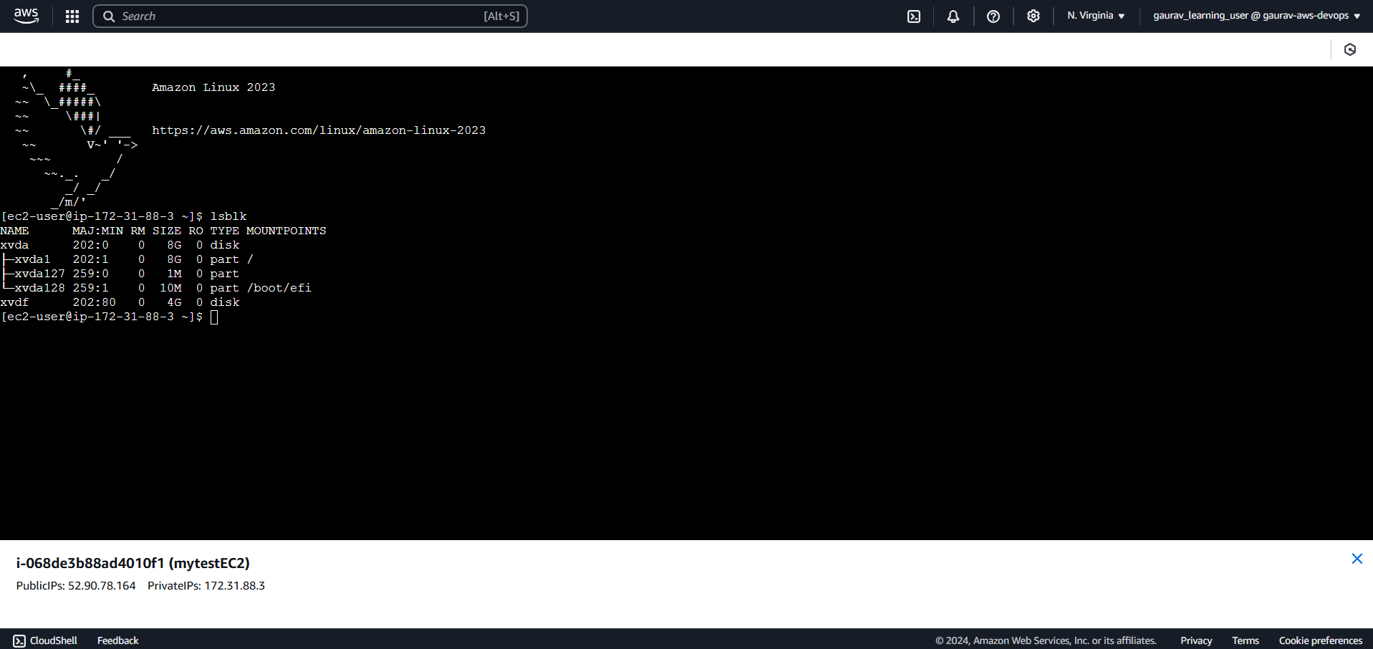

Taking Snapshot

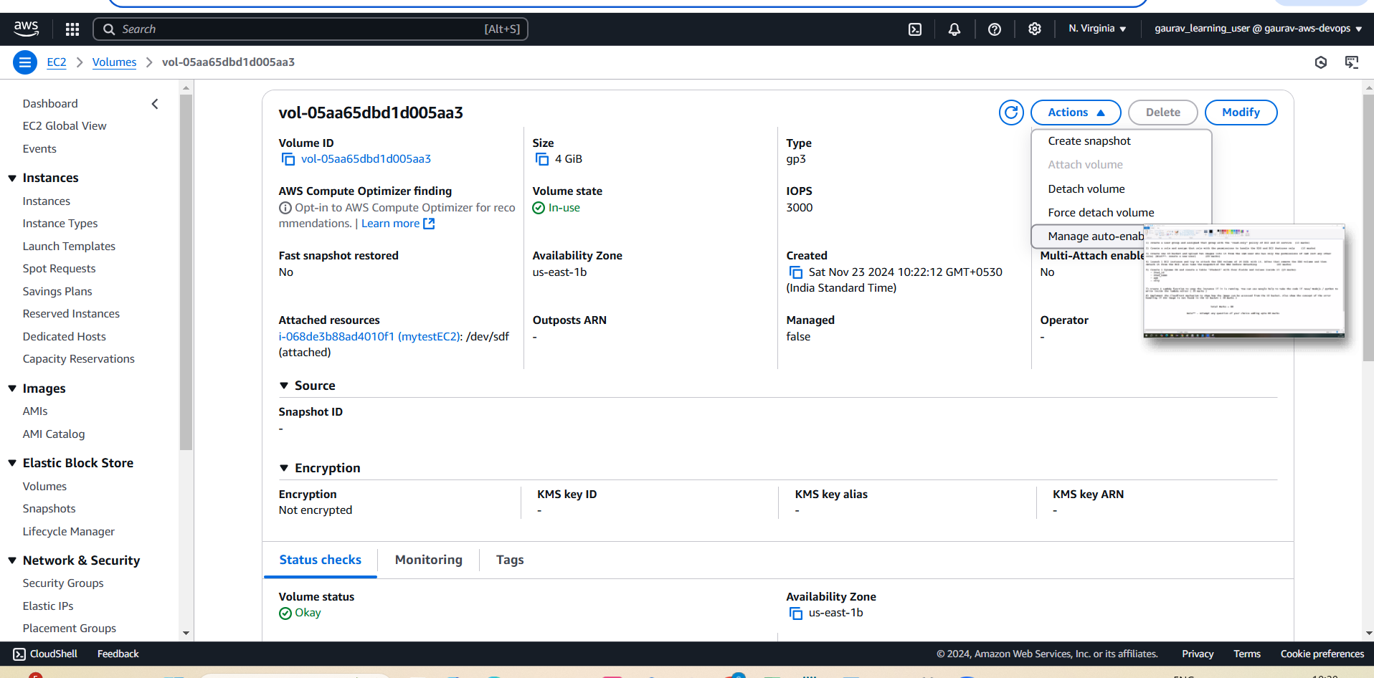

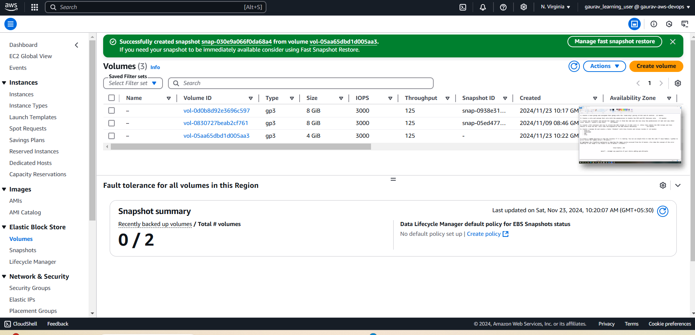

Snapshot created and listing

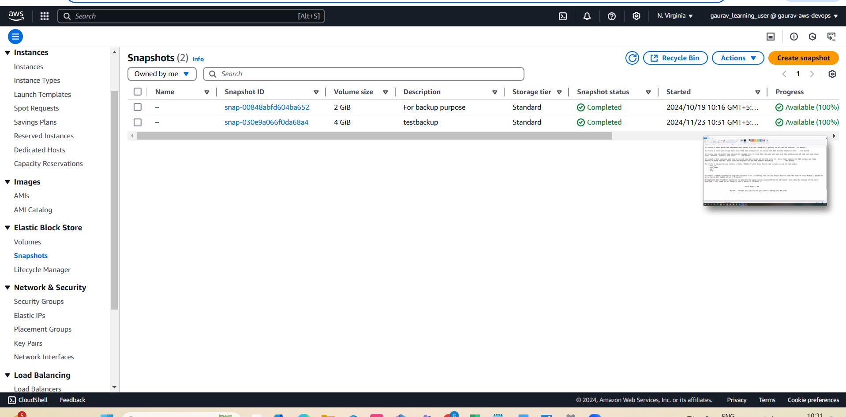

Detached Vol – Status in-use

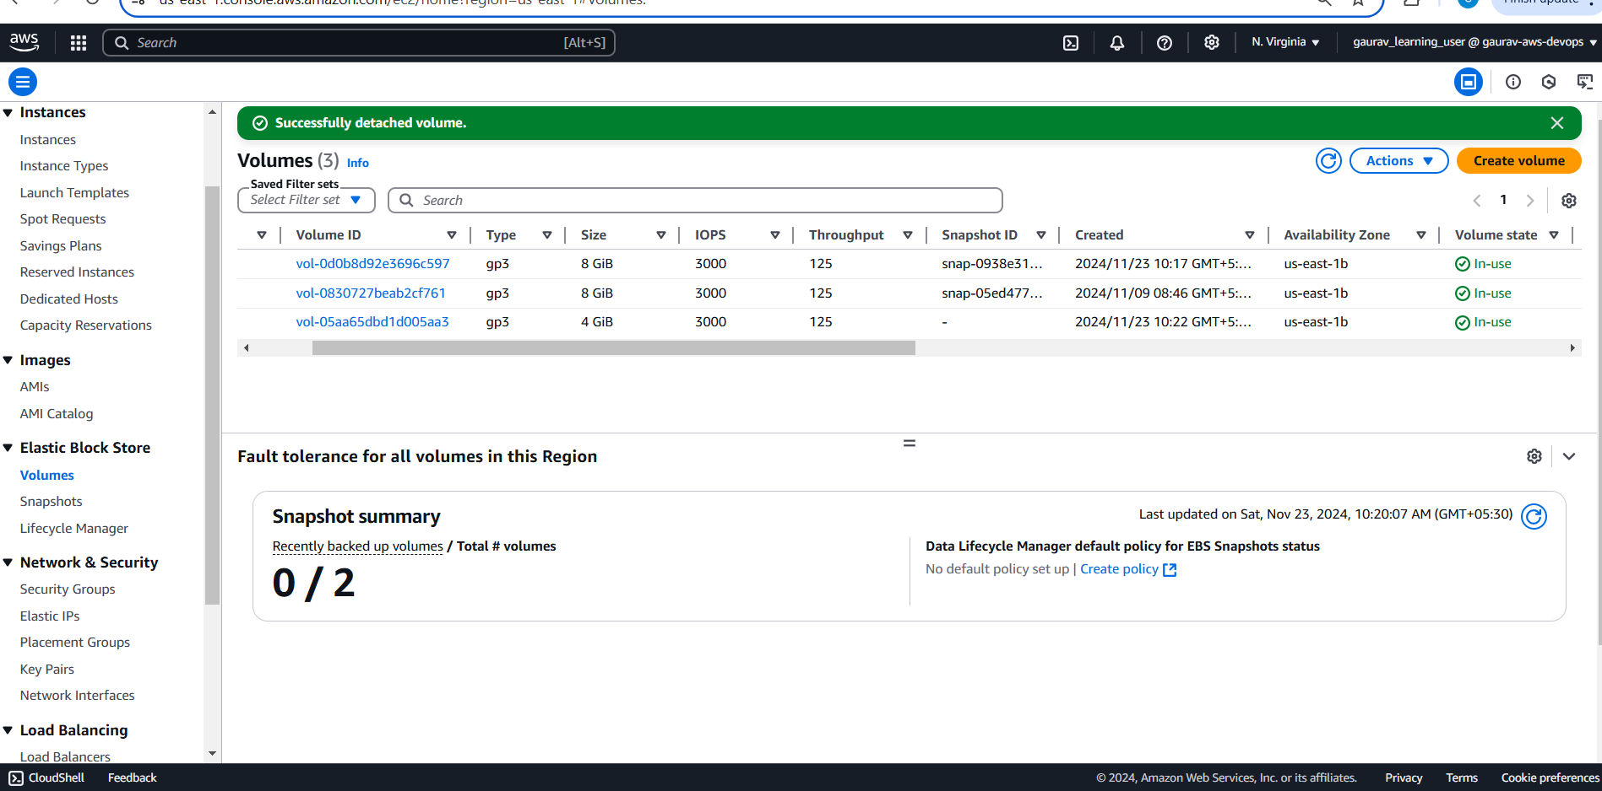

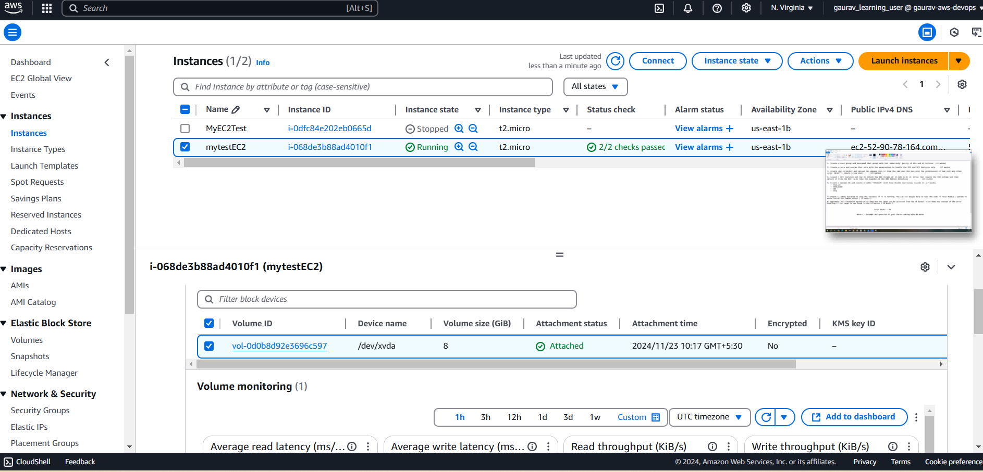

5. Create dynamo DB and create table student with 4 fields

Stud_id

Stud_name

Age

city

Created table with Partition and Sort Key

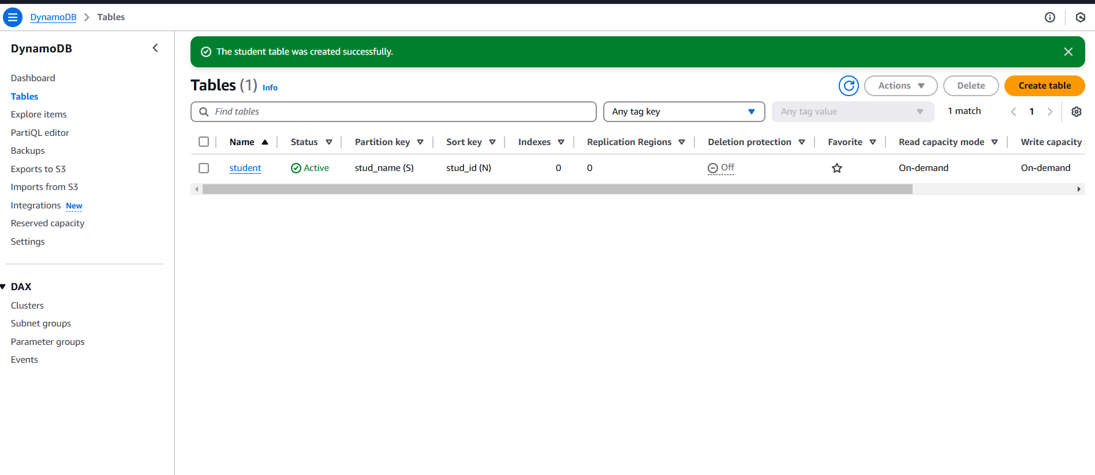

Add 2 new fields with explore items using new attributes

Table created with fields names

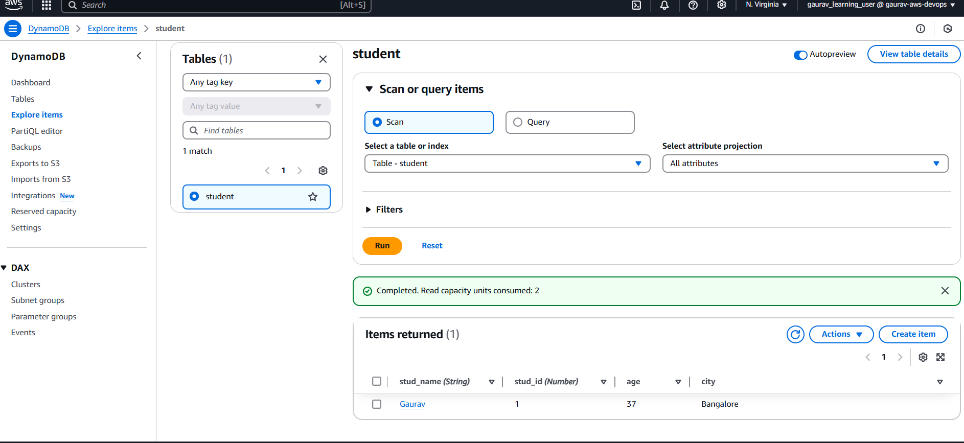

7. Create 1 lambda function to stop instance if it is running

Create function

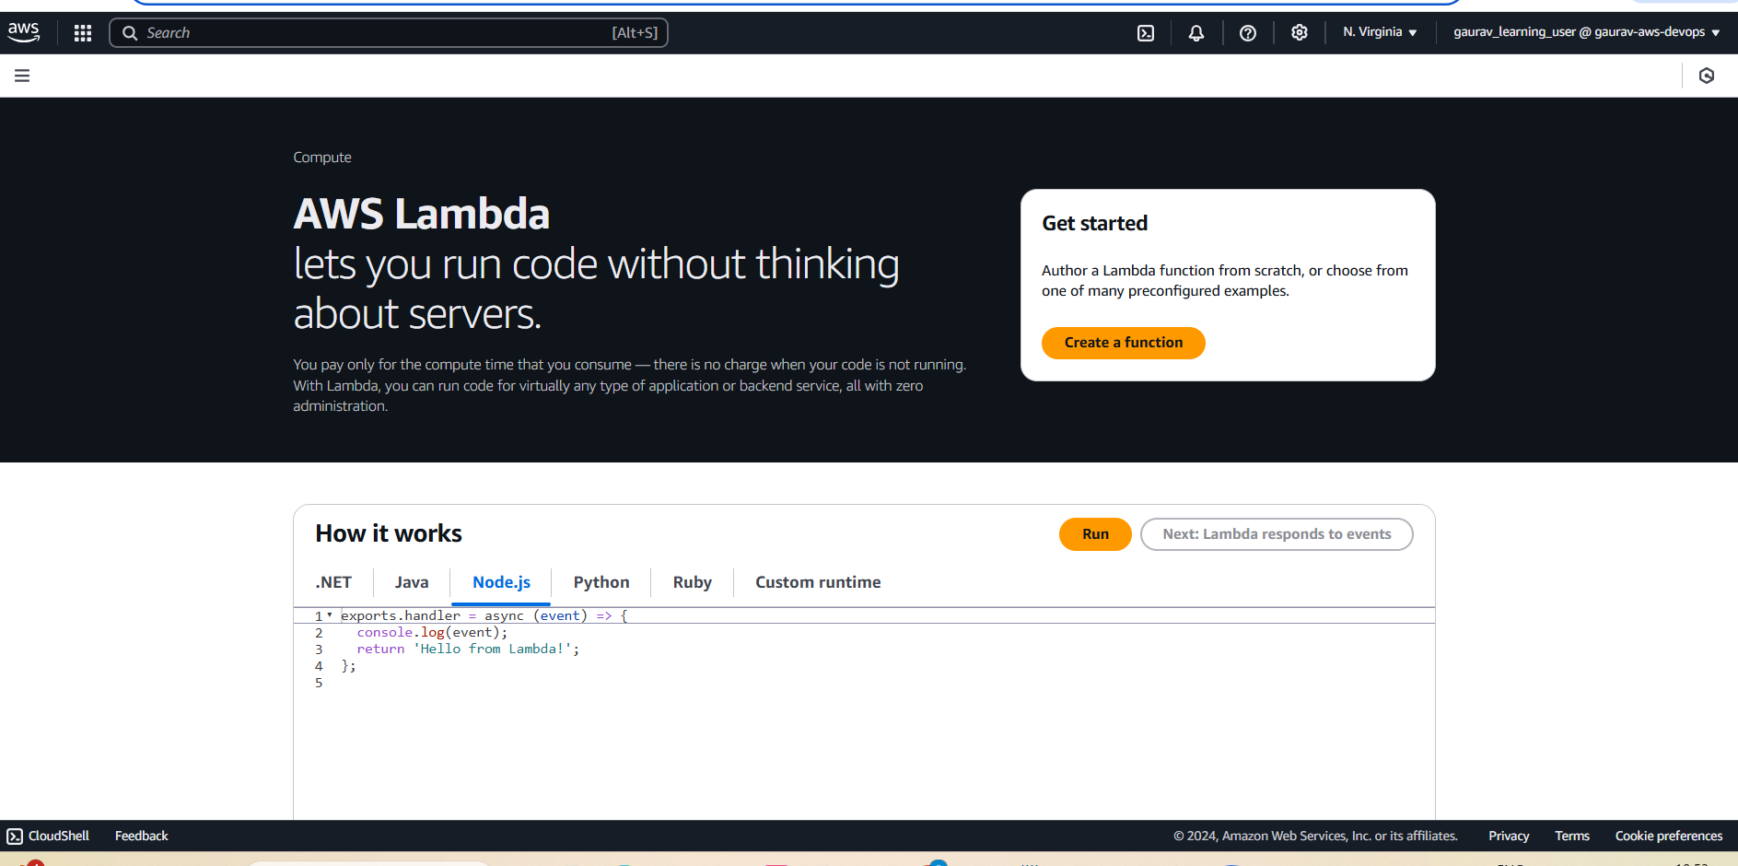

Create policy and create Lambda role

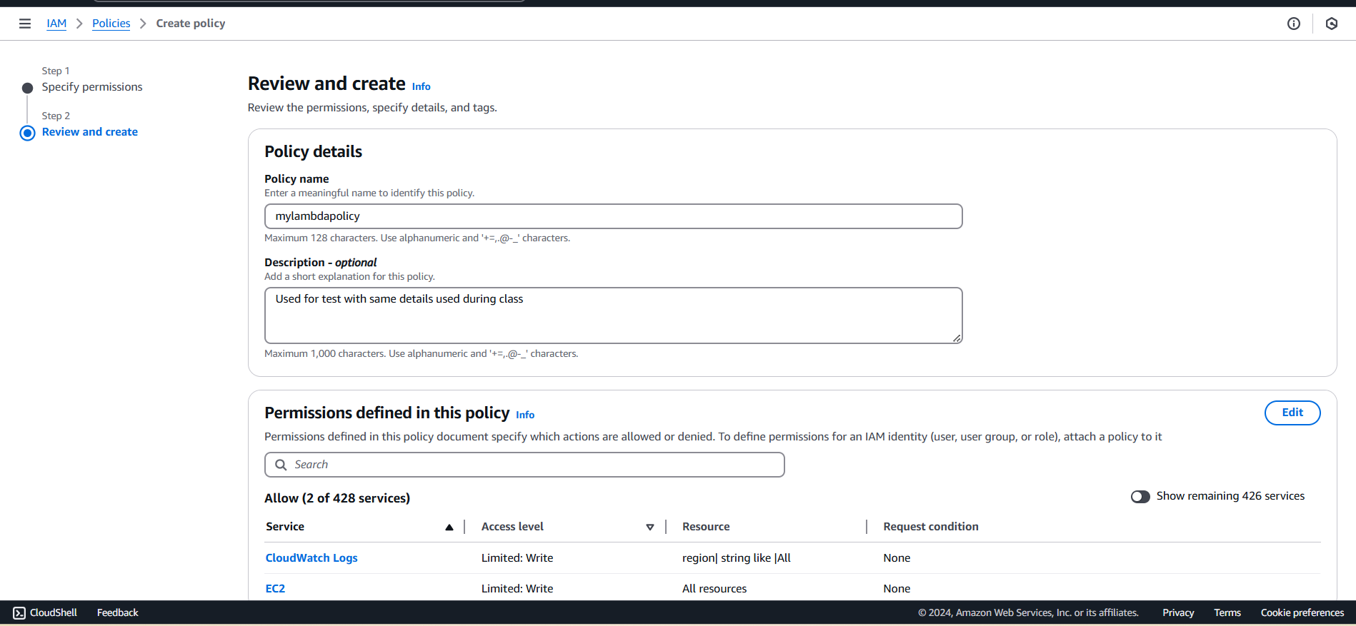

Creating Role now

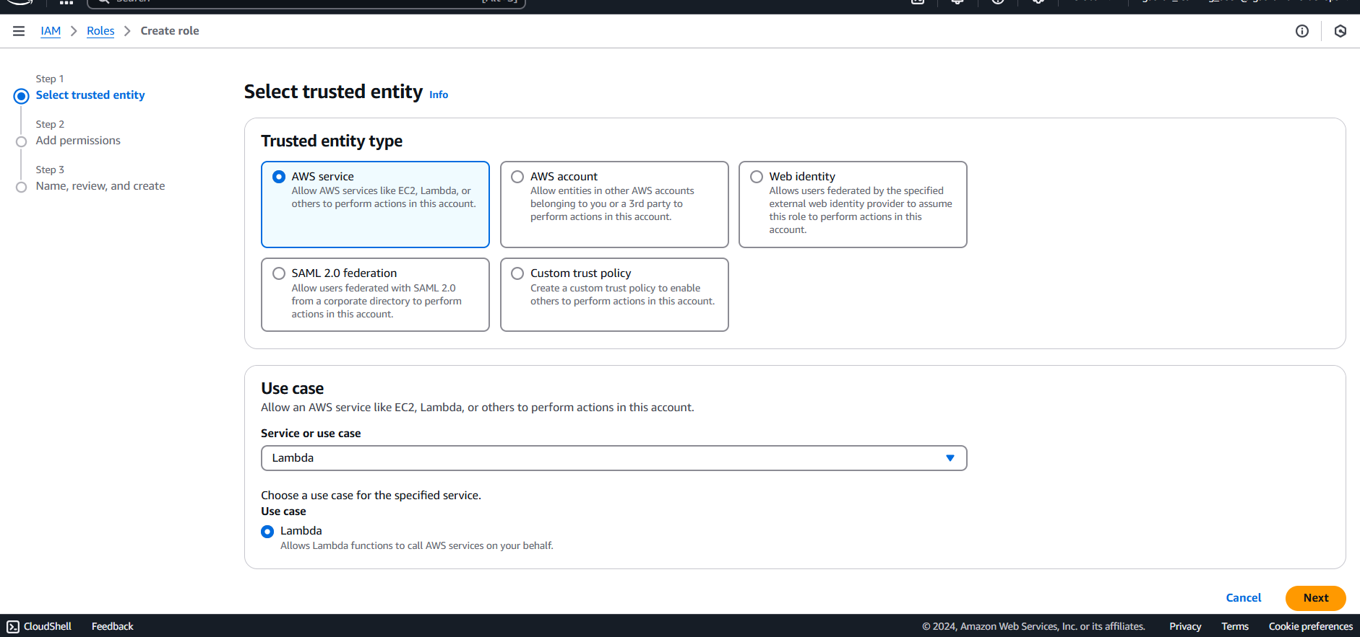



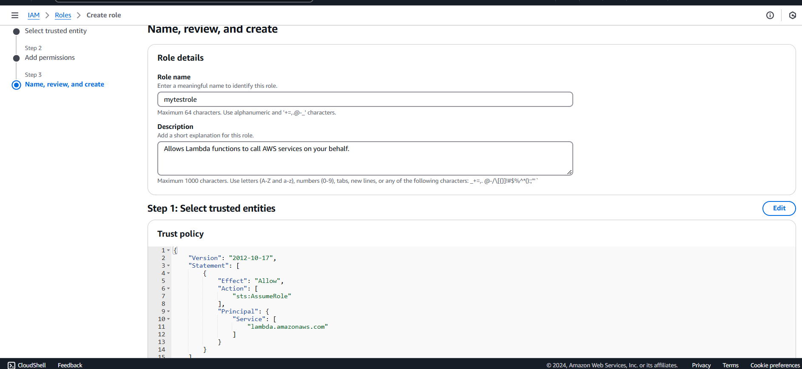

During function creation , now role is reflecting

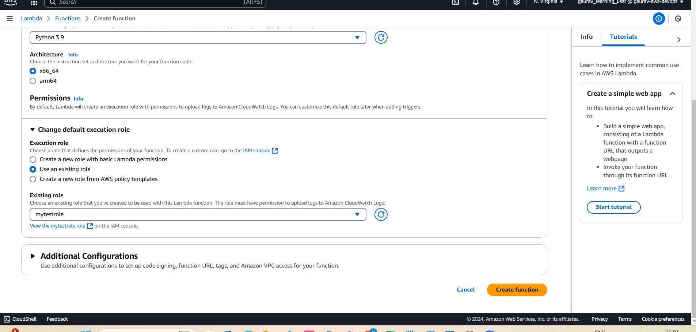

Replaced default Python code with BOTO code used during class using latest created instance and deploy

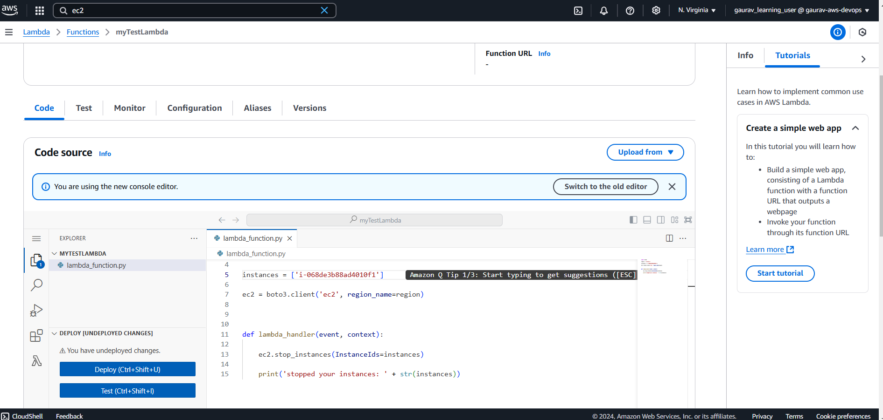

Adding trigger with Regular Expression of UTC time parameter

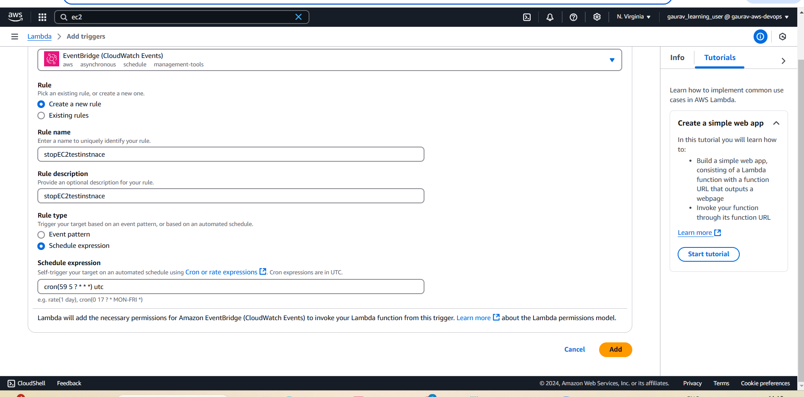

Trigger added to stop at 5.59 UTC, current time is 5.46

